Wall Display Design Notes
17/4/20

Goal
Hardware
* 3 x 2 panel of 8x8 LEDs
* IR control for changing mode
* Temperature – sensor TBD
* Clock – either RTC or web time
- web over complicates it, maybe just RTC module
Constraints
Build with the display modules I have (8x8 common anode).
Assuming ten dots per millisecond, that’s one every 100 uS (~26fps). Gives 800 cycles at ATtiny85 8MHz internal clock. 20 fps = period 125uS = 1000 cycles.
Can only power one LED at a time as most chips limited to 25mA sink/source.

Software
* Aim for 20 fps refresh rate
- 6 * 64 = 384 pixels * 20 = 7680 dots per second = approx 8 dots per millisecond
* Modes
- Date / Time
- Temperature (Min/Max?)
- Game of life
= Random start
= A few predefined starts, e.g. gliders, spaceships, etc.

Hardware Design
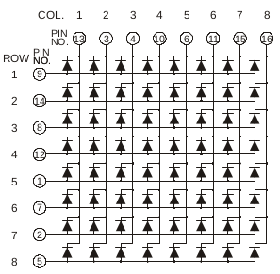
I have 6x 8x8 displays, common anode.

Min MCU Pin Count
6 MCU PINS:
74-138 (inverting decoder) to drive columns
74-238 (non-inverting decoder) to drive rows
OR
74-4051 (mux/demux) for both with Z input L/H as needed.

Intermediate Pin Count (11 pins)
One decoder for row or column, 8 MCU data lines for other.

Min Components (16 pins)
No decoders – need 16 data lines.

Plan
Can this work with just one MCU? Or does it need an MCU per n display modules (to speed up refresh times)?
Breadboard POC will establish what an acceptable refresh rate is for the display to help with scaling up these numbers.

Breadboard POC – Single display version
One 8x8 panel to prove IO and MCU config.
Only have 74LS138 inverting decoders, so for POC will use inverters on outputs for row drivers.
Row drivers from inverters.
From datasheet, each LED 20mA at 2.0V (1.8-2.2)
Driving at 5V, so resistor drops 3V , R = 3V/20mA = 150 Ohms

